Yes. Let's do Thermodynamics properly and exhaustively first. For ChemBase, I would not make Thermodynamics just a list of 10–15 calculators. It should be a complete Thermodynamics Engineering Workspace.
Below is the exact specification/prompt you can give your coding AI.
CHEMBASE — THERMODYNAMICS SUBJECT
Complete Subject Specification + Calculator Library
1. CORE OBJECTIVE
Build the Thermodynamics section as a complete Chemical Engineering learning, calculation, visualization, practice, and analysis workspace.
It should allow a student to:
- Learn thermodynamics concepts
- Find thermodynamic properties
- Solve numerical problems
- Perform cycle analysis
- Work with steam and refrigerants
- Analyze compressors, turbines, pumps and heat exchangers
- Calculate energy and entropy changes
- Practice problems
- Prepare for viva
- Visualize thermodynamic processes
- Ask a specialized Thermodynamics AI Tutor
- Save calculations and work
Do not make this a generic calculator collection.

2. THERMODYNAMICS HOME DASHBOARD
When the student opens:
Subjects → Thermodynamics
show:
📚 Learn
🧮 Calculators
📊 Property Tables
🔄 Cycle Analyzer
📈 Thermodynamic Diagrams
🤖 AI Thermodynamics Tutor
📝 Practice
🎤 Viva
📐 Formula Explorer
⚠️ Common Mistakes
🏭 Industrial Applications
🧪 Lab Analytics
📂 My Work

3. LEARN SECTION
Organize Thermodynamics into the following topics.
A. Basic Concepts
- System
- Surroundings
- Boundary
- Open system
- Closed system
- Isolated system
- State
- Process
- Cycle
- Intensive properties
- Extensive properties
- Equilibrium
- Quasi-static process

B. Thermodynamic Properties
- Pressure
- Temperature
- Volume
- Specific volume
- Density
- Internal energy
- Enthalpy
- Entropy
- Gibbs free energy
- Helmholtz free energy
- Specific heats
- Compressibility factor

C. First Law of Thermodynamics
- Energy conservation
- Closed-system energy balance
- Open-system energy balance
- Steady-flow energy equation
- Heat
- Work
- Boundary work
- Shaft work
- Electrical work
- Enthalpy

D. Second Law
- Kelvin-Planck statement
- Clausius statement
- Reversible processes
- Irreversible processes
- Entropy
- Entropy generation
- Carnot cycle
- Second-law efficiency

E. Pure Substances
- Phase change
- Compressed liquid
- Saturated liquid
- Saturated vapor
- Wet region
- Superheated vapor
- Critical point
- Triple point
- Quality

F. Thermodynamic Relations
- Maxwell relations
- Exact/inexact differentials
- Fundamental property relations
- Joule-Thomson effect
- Clapeyron equation
- Clausius-Clapeyron equation

G. Gas Thermodynamics
- Ideal gases
- Real gases
- Compressibility factor
- Equations of state
- van der Waals
- Peng-Robinson
- Soave-Redlich-Kwong where applicable
- Fugacity concepts where applicable

H. Power Cycles
- Carnot
- Rankine
- Reheat Rankine
- Regenerative Rankine
- Brayton
- Intercooled Brayton
- Reheated Brayton
- Regenerative Brayton
- Otto
- Diesel
- Dual cycle

I. Refrigeration
- Refrigeration principle
- Vapor-compression refrigeration
- Absorption refrigeration
- COP
- Refrigerant properties
- Throttling
- Compressor
- Condenser
- Expansion valve
- Evaporator

4. COMPLETE CALCULATOR LIBRARY
This is the most important part.
Create a Thermodynamics Calculator Hub organized by topic.

A. BASIC PROPERTY CALCULATORS
1. Density
Inputs:
- Mass
- Volume
Output:
- Density

2. Specific Volume
Inputs:
- Volume
- Mass
Output:
- Specific volume

3. Specific Gravity
Inputs:
- Fluid density
- Reference density
Output:
- Specific gravity

4. Pressure Conversion
Convert between:
- Pa
- kPa
- MPa
- bar
- atm
- psi
- mmHg
- Torr

5. Temperature Conversion
Convert:
- °C
- K
- °F
- °R

6. Specific Heat
Calculate heat capacity relationships using:
- mass
- heat
- temperature change
- specific heat
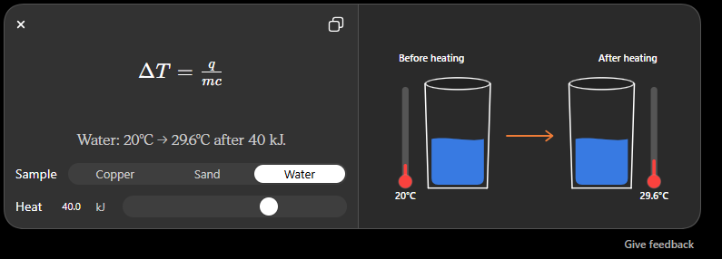
B. HEAT AND WORK
7. Sensible Heat
Calculate:
Q = mcΔT
Allow:
- Constant specific heat
- Temperature-dependent specific heat where supported

8. Latent Heat
Calculate:
Q = mL
Inputs:
- Mass
- Latent heat

9. Heat Capacity
Calculate:
- Total heat capacity
- Molar heat capacity
- Specific heat capacity

10. Boundary Work
Support:
- Constant pressure
- Constant volume
- Polytropic process
For a polytropic process:
PVⁿ = constant
Calculate work.

11. Isothermal Work
For ideal gas:
W = nRT ln(V₂/V₁)
Show assumptions.

12. Adiabatic Work
Support reversible adiabatic/isentropic ideal-gas processes.
Calculate:
- Final temperature
- Final pressure
- Work

13. Polytropic Process Calculator
Inputs:
- P₁
- V₁
- T₁
- P₂/V₂
- n
Calculate remaining properties and work.

C. FIRST LAW CALCULATORS
14. Closed-System First Law
Calculate:
ΔE = Q − W
Support:
- ΔU
- ΔKE
- ΔPE

15. Internal Energy Change
For ideal gases:
ΔU = mCvΔT

16. Enthalpy Change
For ideal gases:
ΔH = mCpΔT
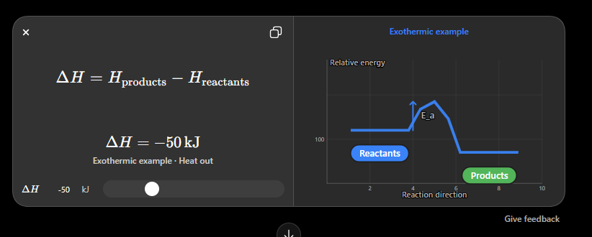
17. Heat Transfer from Energy Balance
Inputs:
- Initial energy
- Final energy
- Work
Calculate required heat.

18. Work from Energy Balance
Calculate work from:
Q − ΔE

D. STEADY FLOW ENERGY EQUATION
19. SFEE Calculator
Support:
- Inlet/outlet enthalpy
- Velocity
- Elevation
- Heat
- Work
Calculate unknown quantity.
Use:
Q − W = ΔH + ΔKE + ΔPE
Allow multiple inlet/outlet streams in advanced mode.

E. ENTHALPY CALCULATORS
20. Sensible Enthalpy Change
Calculate using Cp.
21. Enthalpy of Vaporization
Calculate heat required for phase change.
22. Mixture Enthalpy
Calculate enthalpy for mixtures where applicable.
23. Reaction Enthalpy
Calculate reaction heat using standard enthalpies of formation.
24. Hess's Law Calculator
Student enters multiple reactions and ChemBase calculates the desired reaction enthalpy.

F. ENTROPY
25. Entropy Change — Ideal Gas
Calculate:
Δs = Cp ln(T₂/T₁) − R ln(P₂/P₁)
or equivalent formulation depending on inputs.

26. Entropy Change — Constant Pressure
Calculate:
Δs = Cp ln(T₂/T₁)

27. Entropy Change — Constant Temperature
Calculate:
Δs = −R ln(P₂/P₁)
for appropriate ideal-gas conditions.

28. Entropy Generation
Calculate:
Sgen ≥ 0
for a system/process based on entropy balance.

29. Entropy Balance
Support:
- Heat transfer
- Mass flow
- Entropy generation

30. Isentropic Process Calculator
Calculate:
- P₂
- T₂
- V₂
from known initial conditions and pressure/volume ratio.

G. SECOND LAW
31. Carnot Efficiency
Calculate:
η = 1 − TL/TH

32. COP — Refrigerator
Calculate:
COPR = QL/W

33. COP — Heat Pump
Calculate:
COPHP = QH/W

34. Second-Law Efficiency
Calculate second-law efficiency for relevant systems.

35. Reversible Work
Calculate reversible work where applicable.

36. Lost Work / Exergy Destruction
Calculate:
Exergy destruction = T₀Sgen
Allow:
- Ambient temperature
- Entropy generation

H. PURE SUBSTANCE / STEAM
This should be one of the most important sections in Thermodynamics.
37. Steam Property Lookup
Student enters any suitable combination of:
- Temperature
- Pressure
- Quality
- Enthalpy
- Entropy
- Specific volume
Return:
- T
- P
- v
- u
- h
- s
- x
where applicable.

38. Saturated Steam Properties
Given:
- Pressure OR temperature
Return:
- Tsat
- vf
- vg
- uf
- ug
- hf
- hg
- sf
- sg

39. Wet Steam Calculator
Given:
- Pressure + quality
Calculate:
- v
- u
- h
- s

40. Superheated Steam Calculator
Given:
- Pressure
- Temperature
Return:
- v
- u
- h
- s

41. Compressed Liquid Calculator
Given:
- Pressure
- Temperature
Estimate relevant properties.

42. Steam Quality Calculator
Given appropriate properties such as:
- h
- u
- v
- s
calculate quality x.

43. Steam Table Interpolation
Allow students to select:
- Linear interpolation
- Two-dimensional interpolation where applicable
Show the interpolation process clearly.
Do not simply provide the final number.

I. REAL GAS CALCULATORS
44. Compressibility Factor
Calculate:
Z = PV/nRT

45. Ideal Gas Law
Calculate any missing:
- P
- V
- n
- T

46. van der Waals Equation
Calculate unknown thermodynamic variables.

47. Peng-Robinson EOS
Provide an advanced calculator for real-fluid property estimation.

48. SRK Equation of State
Provide SRK where appropriate.

49. Reduced Properties
Calculate:
- Reduced temperature
- Reduced pressure
- Reduced volume

50. Joule-Thomson Coefficient
Calculate/estimate:
μJT = (∂T/∂P)H
where applicable.

J. MIXTURES
51. Mole Fraction
Calculate component mole fractions.
52. Mass Fraction
Calculate component mass fractions.
53. Average Molecular Weight
Calculate mixture molecular weight.
54. Partial Pressure
Calculate using Dalton's law.
55. Partial Molar Properties
Provide relevant calculations where supported.
56. Mixture Enthalpy
Calculate mixture enthalpy.

K. POWER CYCLES
This should NOT just be a calculator.
Create a:
CYCLE ANALYZER
Student selects a cycle.

57. Carnot Cycle Analyzer
Calculate:
- Heat input
- Heat rejection
- Work
- Efficiency
Generate:
- P-v diagram
- T-s diagram

58. Rankine Cycle Analyzer
Inputs:
- Boiler pressure
- Condenser pressure
- Turbine inlet temperature
- Pump efficiency
- Turbine efficiency
Calculate:
- Pump work
- Turbine work
- Heat supplied
- Heat rejected
- Net work
- Thermal efficiency
- Steam quality
- Back-work ratio
Generate:
T-s diagram
and where appropriate:
h-s diagram

59. Reheat Rankine Cycle
Include:
- Reheat pressure
- Boiler pressure
- Condenser pressure
- Temperatures
Calculate complete cycle performance.

60. Regenerative Rankine Cycle
Support:
- Open feedwater heater
- Closed feedwater heater where feasible
Calculate:
- Extraction fraction
- Work
- Heat input
- Efficiency

61. Brayton Cycle
Calculate:
- Compressor work
- Turbine work
- Heat input
- Heat rejection
- Net work
- Efficiency

62. Intercooled Brayton
Include intercooling.

63. Reheated Brayton
Include reheating.

64. Regenerative Brayton
Include regeneration effectiveness.

65. Otto Cycle
Calculate:
- Compression ratio
- Heat input
- Heat rejection
- Net work
- Efficiency
Generate:
P-v and T-s diagrams

66. Diesel Cycle
Calculate:
- Compression ratio
- Cut-off ratio
- Efficiency
- Work

67. Dual Cycle
Calculate relevant state points and efficiency.

L. REFRIGERATION
68. Refrigeration COP
Calculate:
COP = QL/W

69. Heat Pump COP
Calculate:
COP = QH/W

70. Vapor Compression Cycle Analyzer
Inputs:
- Refrigerant
- Evaporator pressure
- Condenser pressure
- Superheat
- Subcooling
- Compressor efficiency
Calculate:
- Compressor work
- Refrigeration effect
- Heat rejection
- COP
- Mass flow rate
- Power
Generate:
P-h diagram
and:
T-s diagram
where supported.

71. Refrigeration Capacity
Calculate:
- kW
- TR
- Btu/hr where useful

72. Ton of Refrigeration
Convert and calculate refrigeration capacity.

73. Compressor Performance
Calculate:
- Isentropic efficiency
- Work
- Power
- Discharge temperature

74. Throttling Valve
Analyze:
h₁ = h₂
and calculate downstream properties where property data are available.

M. COMBUSTION THERMODYNAMICS
If included in your curriculum, add a dedicated section.
75. Stoichiometric Air Requirement
Calculate theoretical air requirement.
76. Excess Air
Calculate percentage excess air.
77. Air-Fuel Ratio
Calculate:
- Stoichiometric A/F
- Actual A/F
78. Equivalence Ratio
Calculate:
φ
79. Combustion Product Calculation
Given:
- Fuel
- Air
- Excess air
calculate approximate combustion products.
80. Heating Value
Calculate/use:
- HHV
- LHV
where data are available.

N. CHEMICAL THERMODYNAMICS
This is important because ChemBase is specifically for Chemical Engineering, not just mechanical thermodynamics.
81. Gibbs Free Energy
Calculate:
ΔG = ΔH − TΔS
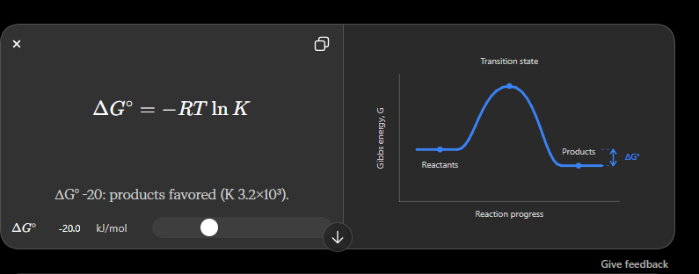
82. Helmholtz Free Energy
Calculate:
A = U − TS

83. Chemical Potential
Provide relevant calculations/explanations.

84. Equilibrium Constant from ΔG°
Calculate:
ΔG° = −RT ln K

85. Reaction Gibbs Energy
Calculate:
ΔG = ΔG° + RT ln Q

86. Equilibrium Constant
Calculate K from thermodynamic data.

87. van't Hoff Equation
Calculate effect of temperature on equilibrium constant.

88. Reaction Enthalpy
Calculate using:
- Standard enthalpy of formation
- Hess's law
- Bond energies where applicable

89. Reaction Entropy
Calculate:
ΔS°reaction
from standard entropy data.

90. Reaction Gibbs Energy
Calculate:
ΔG°reaction
from thermodynamic properties.

O. PHASE EQUILIBRIUM / VLE
This is extremely valuable for Chemical Engineering.
91. Raoult's Law
Calculate:
yi P = xi Pisat
for ideal systems.

92. Bubble Point Pressure
Calculate bubble pressure for mixtures.

93. Dew Point Pressure
Calculate dew pressure.

94. Bubble Point Temperature
Calculate bubble temperature.

95. Dew Point Temperature
Calculate dew temperature.

96. Relative Volatility
Calculate:
α

97. K-value Calculator
Calculate:
Ki = yi/xi

98. VLE Flash Calculation
Create an advanced tool for:
- Feed composition
- Pressure/temperature
- Equilibrium data
Output:
- Vapor fraction
- Liquid composition
- Vapor composition
This can later connect directly with the Separation Processes module.

P. THERMODYNAMIC DIAGRAMS
Create a dedicated:
Diagram Studio
Support, where applicable:
- P-v
- T-v
- P-T
- T-s
- h-s
- Mollier diagram
- P-h
- Phase diagrams
- VLE diagrams
Students should be able to:
- Select process
- Enter initial/final conditions
- Plot process path
- Add state points
- Label states
- Save graph

Q. INTERACTIVE CYCLE BUILDER
This should be a flagship ChemBase feature.
Student selects:
Rankine / Brayton / Otto / Diesel / Refrigeration / Carnot
Then ChemBase displays a visual cycle.
Student can change:
- Pressure ratio
- Temperature
- Compression ratio
- Turbine efficiency
- Compressor efficiency
- Condenser pressure
- Boiler pressure
- Reheat pressure
- etc.
The system recalculates the cycle and updates the diagram.
Show:
State 1 → State 2 → State 3 → State 4
with:
- P
- T
- v
- h
- s
- quality where applicable

R. PROPERTY DATABASE
Do not hard-code random values into individual calculators.
Create a centralized:
Thermodynamic Property Database
It should eventually support:
- Water/steam
- Common refrigerants
- Air
- Nitrogen
- Oxygen
- Hydrogen
- Carbon dioxide
- Methane
- Ethane
- Propane
- Butane
- Common Chemical Engineering fluids
The database should be expandable.
Every calculator should use this shared property system wherever applicable.

S. AI THERMODYNAMICS TUTOR
The AI should understand the entire Thermodynamics knowledge base.
Student can ask:
"Why is enthalpy used in the steady-flow energy equation?"
or:
"Why does entropy increase in an irreversible process?"
or:
"I don't understand the Rankine cycle."
AI should answer using:
- Concepts
- Equations
- Examples
- Diagrams where appropriate
- Engineering interpretation

T. AI PROBLEM SOLVER
Student can paste a complete thermodynamics problem.
AI should identify:
Topic → Given → Find → Assumptions → Formula → Solution → Answer → Interpretation
Example:
Steam enters a turbine at...
ChemBase should identify:
Thermodynamics → Rankine/Steam/Turbine problem
and use the appropriate property information.

U. PRACTICE SYSTEM
Create:
Basic
Conceptual + simple numerical.
Intermediate
Multi-step numerical problems.
Advanced
University-level examination problems.
Challenge
Complex engineering problems involving multiple concepts.
The AI should generate different questions rather than repeating a fixed bank.

V. VIVA
Thermodynamics Viva should dynamically ask about:
- Laws
- Properties
- Equations
- Cycles
- Steam
- Refrigeration
- Entropy
- Equipment
- Assumptions
- Physical interpretation
The number of questions should be dynamic.
Do NOT always ask exactly 10.
Adapt difficulty based on answers.

W. FORMULA EXPLORER
Every formula should have:
Formula
Variables
Units
Physical meaning
When to use
Assumptions
Example
Common mistake
For example:
ΔG = ΔH − TΔS
Explain:
- What ΔG means
- What ΔH means
- What ΔS means
- Temperature requirement
- Sign interpretation
- Relation to spontaneity
- Relation to equilibrium

X. COMMON MISTAKES
Create Thermodynamics-specific mistakes such as:
- Confusing heat and temperature
- Confusing enthalpy and internal energy
- Wrong sign convention
- Using gauge pressure incorrectly
- Using °C instead of K in thermodynamic equations
- Forgetting kinetic/potential energy terms
- Incorrect steam-table region
- Incorrect quality interpretation
- Using ideal-gas assumptions incorrectly
- Confusing COP with efficiency
- Mixing kJ and J
- Incorrect interpolation
- Incorrect state identification

Y. INDUSTRIAL APPLICATIONS
Add:
Where Thermodynamics is Used
Examples:
- Boilers
- Steam turbines
- Gas turbines
- Refrigeration
- HVAC
- Compressors
- Pumps
- Power generation
- LNG
- Petrochemical plants
- Refineries
- Chemical reactors
- Heat recovery
- Waste heat recovery
For each application explain:
Thermodynamic principle → Equipment → Industrial purpose

Z. LAB ANALYTICS CONNECTION
Thermodynamics must connect to the existing ChemBase Lab Analytics.
Possible labs:
- Bomb calorimeter
- Refrigeration cycle
- Heat engine
- Steam generation
- Boiler
- Calorimetry
- COP determination
- Specific heat
- Thermal efficiency
When a student selects a Thermodynamics lab:
Subject → Equipment → Experiment → Objective → Theory → Data → Calculations → Graph → Results → Conclusion → Safety → Viva
Use the shared Equipment Knowledge Base.

AA. SAVED WORK
Students should be able to save:
- Calculator results
- Property lookups
- Cycle analyses
- Graphs
- Solved problems
- Practice attempts
- AI explanations
- Lab work
Organize everything under:
My Thermodynamics Work

AB. UNIT HANDLING
This is mandatory.
Every calculator should have proper units.
Allow conversions such as:
- Pa ↔ kPa ↔ MPa ↔ bar ↔ atm ↔ psi
- J ↔ kJ
- W ↔ kW
- J/kg ↔ kJ/kg
- °C ↔ K ↔ °F
- m³ ↔ L
- kg/s ↔ kg/h
The system should internally use consistent SI units for calculations.
Show the student the selected units.

AC. CALCULATION TRANSPARENCY
Never simply show:
Answer = 245.6 kJ
Instead show:
Given
Formula
Substitution
Calculation
Final Answer
Engineering Meaning
The student should be able to understand how the answer was obtained.

AD. ERROR HANDLING
If required data are missing:
Do NOT guess.
Tell the student:
"To calculate turbine work, I need either the inlet/outlet enthalpies or sufficient state information to determine them."
If assumptions are necessary:
Show:
Assumptions
and allow the student to modify them.

AE. THERMODYNAMICS FLAGSHIP FEATURE
The Thermodynamics section should prominently feature:
THERMODYNAMIC SOLVER
Student can enter almost any Thermodynamics problem.
ChemBase should determine:
What type of problem is this?
Examples:
- Property problem
- First Law
- SFEE
- Entropy
- Steam
- Cycle
- Refrigeration
- Real gas
- Chemical thermodynamics
- VLE
- Combustion
Then automatically recommend the correct tool.
This makes the subject feel intelligent rather than like a menu of calculators.

FINAL THERMODYNAMICS STRUCTURE
The final interface should approximately be:
THERMODYNAMICS
│
├── 📚 Learn
│
├── 🧮 Calculators
│ ├── Properties
│ ├── Heat & Work
│ ├── First Law
│ ├── Second Law
│ ├── Entropy
│ ├── Steam
│ ├── Real Gases
│ ├── Mixtures
│ ├── Cycles
│ ├── Refrigeration
│ ├── Combustion
│ ├── Chemical Thermodynamics
│ └── VLE
│
├── 📊 Property Database
│
├── 🔄 Cycle Analyzer
│
├── 📈 Diagram Studio
│
├── 🤖 AI Thermodynamics Tutor
│
├── 🧠 Thermodynamics Problem Solver
│
├── 📝 Practice
│
├── 🎤 Viva
│
├── 📐 Formula Explorer
│
├── ⚠️ Common Mistakes
│
├── 🏭 Industrial Applications
│
├── 🧪 Lab Analytics
│
└── 📂 My Work
Most important point
Do not implement all 90+ calculators as isolated cards.
Group them intelligently, and build shared calculation engines underneath them.
For example, the Steam calculators should all use the same Steam Property Engine. The cycle analyzers should use the same property engine. The refrigeration tools should use the same refrigerant/property engine.
That way, when you add a new substance or improve the property calculation backend, all relevant Thermodynamics tools automatically become better.
This is the level I'd target for ChemBase's Thermodynamics module.

